Nada Shabout

876 words

**Azzawi, Dia (1939-)**

Born in Baghdad, Iraq, Dia Azzawi has been based in London since 1976. A very versatile and prolific artist, his career spans some of Iraq's most important and remarkable experiments, as well as negotiates his relationship of home and exile. Azzawi’s work includes paintings, sculptures, prints, drawings and books. After earning a degree in archaeology from Baghdad University in 1962, Azzawi pursued a BA from the Baghdad Institute of Fine Arts in 1964. He was a founding member of the New Vision Group (Jama’t al-Ru’yya al-Jadidah) in Baghdad, which included artists Rafa al Nasiri, Mohammed Muhriddin, Ismail Fattah, Hachem al-Samarchi, and Saleh al-Jumaie. As a student, he joined Hafidh al-Droubi’s Impressionist Group, and later joined the One-Dimension Group (Jama’t al-Bu’d al-Wahid), established by Shakir Hassan Al Said.

Distinctive in Azzawi's work has been the passion and intensity of his intuitive and vibrant colors. His interest in the relationship between text and image has spanned his career and was transformed through various experiments. Widely exhibited around the world, Azzawi is a pivotal figure in the history of Iraqi and Arab art.

Inheritors of the philosophy initiated by the Baghdad Group of Modern Art, founded by Jewad Selim and Shakir Hassan Al Said in 1951, Azzawi and his generation further explored the notion of *Istilham al-Turath* (seeking inspiration from tradition). Azzawi mined the history of Iraq without discrimination but also went beyond the borders of Iraq. He accepted the heritage and cultural history of the Arab world as part of his own. Equally, he was troubled by all the political upheaval and humanitarian suffering of the region. Contemporary conflicts, wars, mythology, history and literature are all topics of Azzawi’s work articulated and deconstructed through what he termed "epical contemporaneity," where the contemporary mundane is negotiated on an epic scale.

A particularly unique experiment in Azzawi’s work is the book or *daftar* (Arabic for notebook; pl. dafatir). A contemporaneous evaluation of the Islamic concept of the book with its symbolic and literal unity of the arts, Azzawi’s daftar harmonizes a new dialectical coexistence between text and image. The book as a sculptural form dominates both text and image and offers dynamic and interchangeable structures that allow both reading and viewing. Azzawi produced a number of original, hand-painted, one-copy books centering on the work of contemporary Arab poets. The book instead necessitates mediation between text and image. The text of the poem is no longer intrinsic to the book. To Azzawi, these “visual poetic constructions" are not "boxes containing words and few illustrations.” Instead they embody a dialogue between “text-memory and painting-vision” evoked by the spirit of the poem.

Azzawi has served the art world in various capacities, as an educator, an administrator, a patron and curator. He was the director of the Iraqi Antiquities Department in Baghdad between 1968 and 1976 and an art adviser to the Iraqi Cultural Center in London from 1977 until 1980. He was editor-in-chief of *UR* Magazine, London, between 1978 and 1984 and *Funoun Arabbiya*, London, in 1981–82, and a member of the editorial board of *Jusour* Magazine, Washington, DC, in 1992. He has been an advisor to Mathaf: Arab Museum of Modern Art from the time of its planning.

Azzawi has participated in numerous group exhibitions in Beirut, Rome, Vienna, Baghdad, Paris, and London. His work also has been included in a number of international expositions, including the 1976 Venice Biennale, the 1979 Sao Paolo Biennale, and the 1992 International Cairo Biennial, in which he was awarded a jury prize. Solo presentations of his paintings and graphic and book works have been held in Baghdad, Paris, Geneva, Kuwait City, Tripoli, Abu Dhabi, Toronto, Amman, Stockholm, and Washington D.C. among other centers. Institutions that have collected his work include Mathaf: Arab Museum of Modern Art in Qatar, the Institut du Monde Arabe in Paris, the British Museum and the Victoria and Albert Museum in London, and national museums of modern art in Syria, Tunisia, and Jordan.

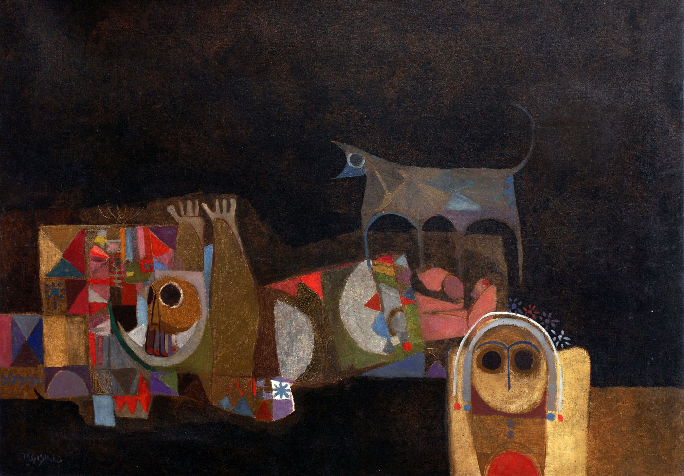

Dia Azzawi, CRYING WOLF, 1968. Oil on Canvas, 84 x 108 cm, Private Collection, London.

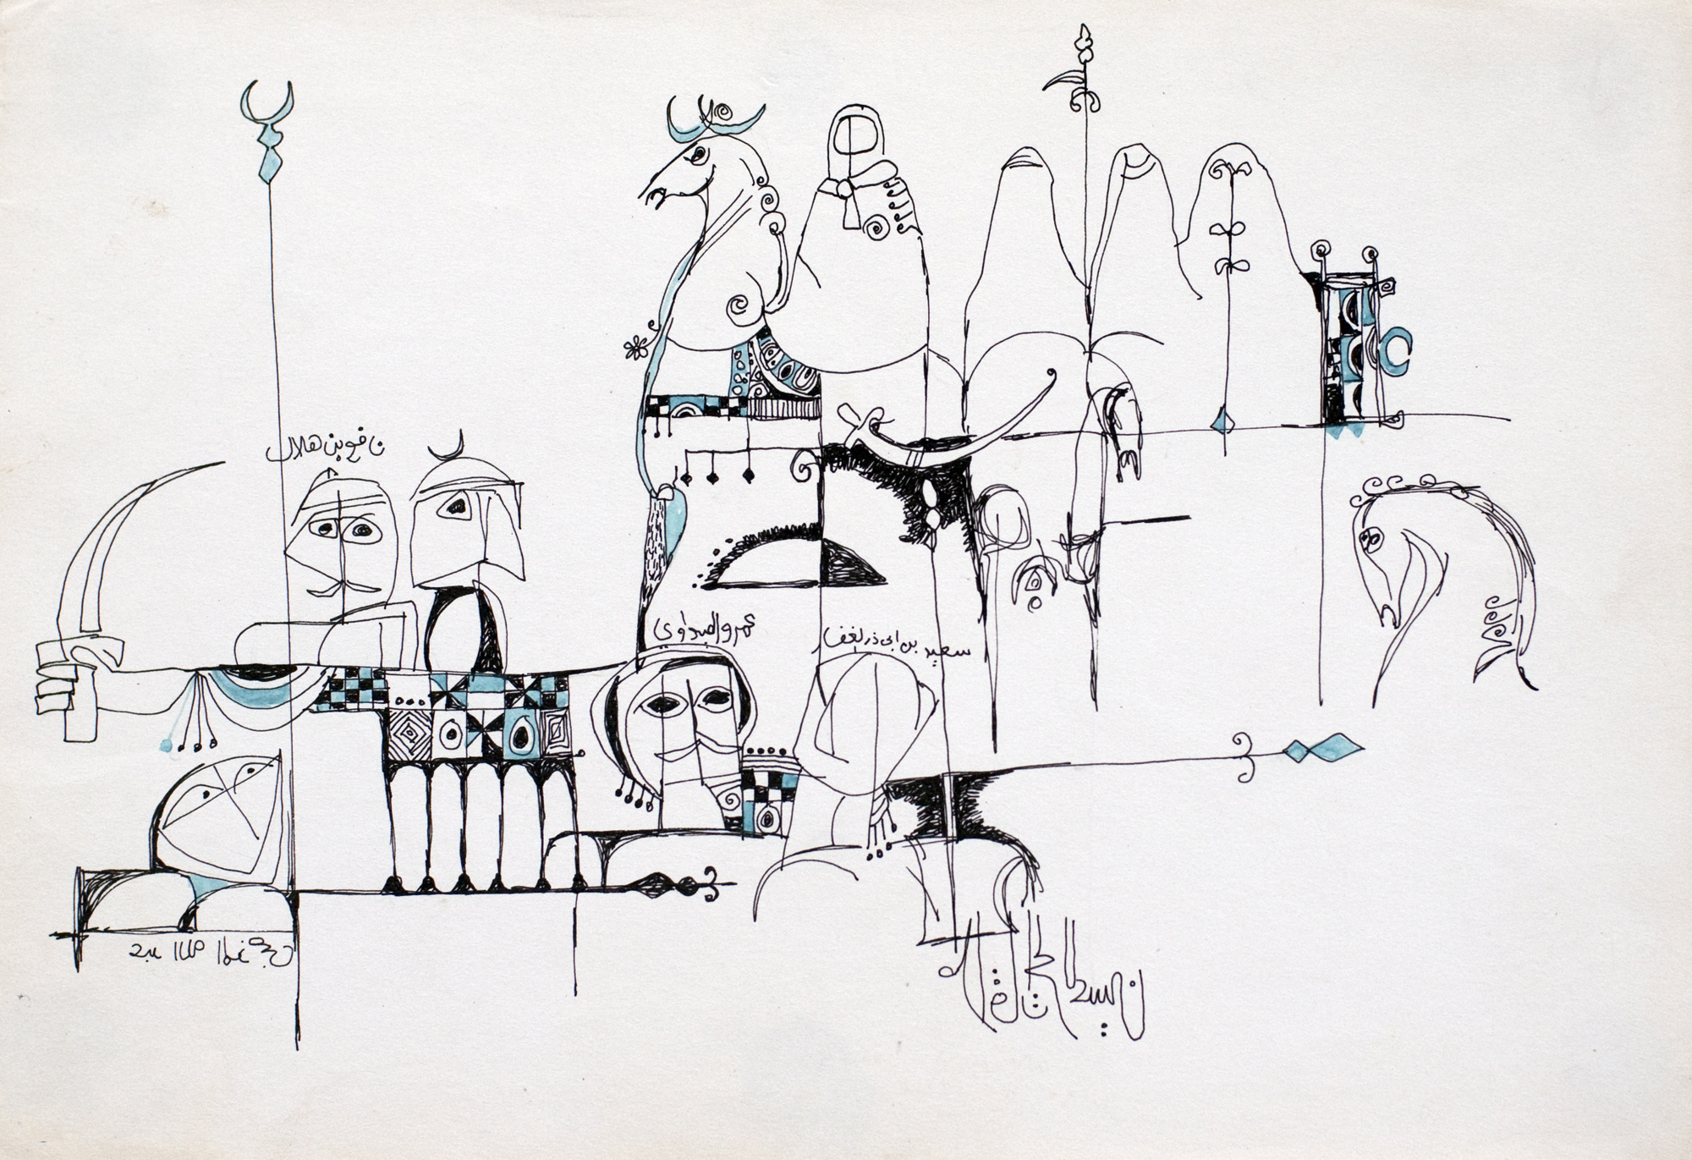

Dia Azzawi, TRAGEDY OF KARBALA (NO.2), 1968. China Ink on Paper, 20 x 30 cm, Private Collection, London.

N.B. The author has obtained permission for both of these images.

**References and further reading**:

Ali, Wijdan (1997) *Modern Islamic Art: Development and Continuity*, Gainesville: Florida University Press.

Al-Azzawi (1991) “Exhibition Catalogue,” Riwaq al-Funun, Tunisia, 14 June–10 July.

Bahrani, Zainab, and Nada Shabout (2009) *Modernism and Iraq*, New York: Columbia University.

Dagher, Charbel (1990) *Al-Hurufiyah al-’Arabiyah: Fann wa Hawiyah* (Arab Letterism: Art and Identity), Beirut: Sharikat al-Matbua’t Lil Tawzi’ wa al-Nashir.

Naef, Silvia (1996) *A la recherche d’une modernité arabe: l’évolution des arts plastiques en Egypte, au Liban et en Irak*, Geneèvae: Slatkine.

Shabout, Nada (2007) *Modern Arab Art: Formation of Arab Aesthetics*, Gainesville: University Press of Florida.

**Shabout, Nada, al-Khudairi, Wassan and Chalabi, Deena (2010)** *Sajjil: A Century of Modern Art*, Doha: Arab Museum of Modern Art, Qatar Museum Authority.

Shabout, Nada M. (ed.) (2010) *Interventions: A Dialogue Between the Modern and the Contemporary*, Doha: Arab Museum of Modern Art, Qatar Museum Authority.

_______ (2009) “Iraqi Art: Dafatir” in *The State of the Arts in the Middle East,* by the Middle East Institute (MEI) Project, special edition of *Viewpoints.*

_______2009, “Dia al-Azzawi” in *Dia al-Azzawi: Retrospective****,*** Abu Dhabi: Meem for ADMAF, 2009: 1-27.